**PIG & STOP**

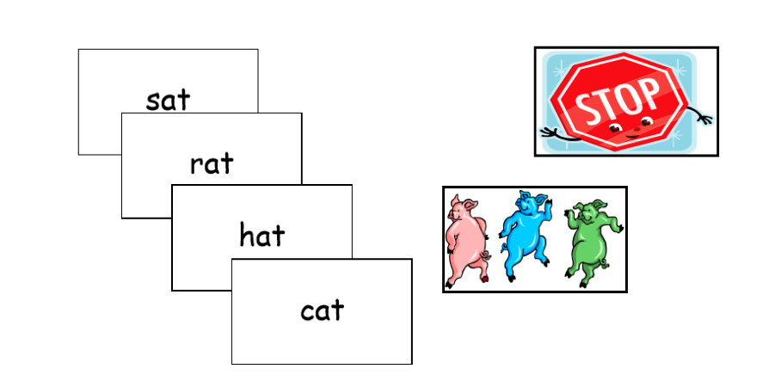

**Number of Players:** 2 to 4.  
**Materials**: 4 Pig and 4 Stop Cards, plus a double set of word cards from the list being

practiced.  
**Object**: Collect the most cards.

**Directions**: Add the 4 Pig and 4 Stop cards to the word cards. At the end of the game sort the Pig and Stop cards out so the word cards can be used for other games.

Begin play by turning all the cards upside down and spreading them over the table. The first player declares how many words he thinks he can correctly read (limit of 1 to 4) before getting a PIG or STOP card. He then chooses one card at a time and reads each word as he chooses the card. His turn continues until he reads the number declared, misses a word, or until he draws either a PIG or STOP card. A STOP card automatically ends the turn. The child may keep any words chosen and read correctly. A PIG card automatically ends the turn and any words chosen and read correctly in that turn have to go back to the table. Play continues until only the 4 PIG and 4 STOP cards remain.

© B.U.S.D. http://www.theschoolbell.com/Links/Dolch/Contents.html